**OOP**

Assignment-01

Question-01:

You are given a 2D array having some elements as shown below. Your task is to remove all zero elements from the array by making a new 2D array and assign it only the non-zero elements. Assume that rows and columns of the input array are defined by the user.

**Screenshot of .exe file:**

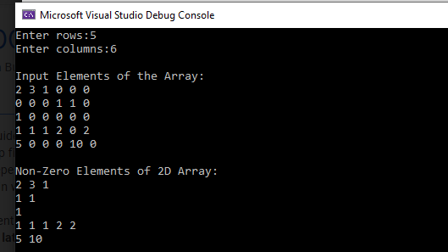

Question 2:

You are given a 2D binary array, where there are only 1’s and 0’s in the array. Your task is to compress the input binary array by counting ones and create new array which will contains the count of ones and second column will contains the digit 1. Further, you need to use the compressed array to transform it to the original input array. (Note: you can use another 2D array as intermediate array). Use intermediate 2D array for the location of 1 (or 0). In this 2D array the first row will contain the location of 1.

**Screenshot of .exe file**

